SCHEME OF LEARNING- WEEK 12
BASIC ONE
Week Ending: |  | DAY: |  |  |  |  | Subject: History
Duration: 60mins per lesson |  |  |  |  |  |  | Strand: My Country Ghana
Class: B1 |  | Class Size: |  |  |  |  | Sub Strand: Some selected individuals
Content Standard:  B1.2.5.1. Show understanding of significant roles played by Ghanaians from different walks of life |  |  |  |  | Indicator:  B1.2.5.1.1 Identify Ghanaians of diverse fields who have contributed significantly to national development |  |  |  | Lesson:  1 OF 1
Performance Indicator:  Learners can Identify Ghanaians of diverse fields who have contributed significantly to national development |  |  |  |  |  | Core Competencies:  Learners to become critical thinkers and digital literates
Teaching/ Learning Resources |  |  | Wall charts, wall words, posters, video clip, etc.
New words |  |  | scared, excited, funeral, festival
References: History Curriculum Pg. 5
DAYS | PHASE 1: STARTER |  |  | PHASE 2: MAIN |  |  |  | PHASE 3: PLENARY
 | Show pictures of Amon Kotei to learners for them to talk about it.  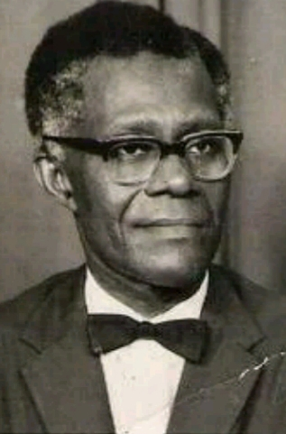 |  |  | Identify Ghanaians of diverse professions who have contributed significantly to national development.  e.g. Amon Kotei  NII AMON KOTEI  Nii Amon Kotei was born on 24th May 1915, at La, near Accra, and belonged to the Ga tribe and trained as a surveyor. He was a distinguished artist and designed the Ghana coat of arms on 4 March 1957. He studied under a scholarship at Achimota school and later received a scholarship to study art at the London school of printing and graphic Art. He received several awards.  Let learners observe some artworks produced by Amon Kotei. |  |  |  | Ask learners series of questions to review their understanding of the lesson  Ask learners to summarize what they have learnt  Learners to read and spell the key words on the board.
 | Ask learners questions to review their understanding in the previous lesson. |  |  | Guide learners to study more about Amon Kotei and talk of his achievements using the internet.  Role play what learners want to be in future |  |  |  | Ask learners series of questions to review their understanding of the lesson  Ask learners to summarize what they have learnt

